**IMPORTANT QUESTIONS - PART B WITH ANSWERS**

**UNIT - I**

1. **Classical Approaches of Management**

i) Scientific Principles of Management

ii) General Administrative Theory

**i) Scientific Principles of Management**

1. **Taylor’s Scientific Management Principles:**
   * **Develop a science for each element** of an individual’s work to replace the old rule-of-thumb method.
   * **Scientifically select and then train**, teach, and develop the worker
   * **Heartily cooperate** with the workers to ensure that all work is done in accordance with the principles of the science that has been developed
   * **Divide work and responsibility** almost equally between management and workers. Management does all work for which it is better suited than the workers
2. **Frank and Lillian Gilbreth**
   * Frank and his wife Lillian, a psychologist, studied work **to eliminate inefficient hand-and body motions.**
   * The Gilbreths also experimented with the design and **use of the proper tools and equipment** for optimizing work performance

**ii) General Administrative Theory**

1. Fayol’s 14 Principles of Management. Or Fayols’s contribution towards the management

**MANAGEMENT THOUGHTS BY HENRI FAYOL**

Fayol developed fourteen most important principles of management as given below

**1. Division of Work**

* All kinds must be divided & subdivided and allotted to various persons

according to their expertise in a particular area.

* Subdivision of work makes it simpler and results in efficiency.
* When employees are specialized, output can increase because they become increasingly skilled and efficient.

**2. Authority**

* Managers must have the authority to give orders, but they must also keep in mind that with authority comes responsibility.

**3. Discipline**

* According to Fayol, Discipline means sincerity, obedience, respect of authority & observance of rules and regulations of the organization.
* Discipline must be upheld in organizations, but methods for doing so can vary.

**4. Unity of Command**

* Employees should have only one direct supervisor.
* Employees should receive orders and be accountable to one and only one supervisor at a time.

**5. Unity of Direction**

* According to this principle, efforts of all the members of the organization should be directed towards a common goal.
* Teams with the same objective should be working under the direction of one manager. This will ensure that action is properly coordinated.

**6. Subordination of Individual Interests to the General Interest**

* The interests of one employee should not be allowed to become more important than those of the group. This includes managers.

**7. Remuneration**

* The quantum and method of remuneration to be paid to the workers should be fair, reasonable, satisfactory & rewarding of the efforts.
* Wages should be determined on the basis of cost of living, work assigned, financial position of the business, wage rate prevailing etc.
* Fayol also recommended provision of other benefits such as free education, medical & residential facilities to workers.
* Employee satisfaction depends on fair remuneration for everyone.

**8. Centralization**

* Centralization means concentration of authority at the top level.
* Centralization is a situation in which top management retains most of the decision making authority.
* Decentralization means disposal of decision making authority to all the levels of the organization.

**9. Scalar Chain**

* Fayol defines scalar chain as ‘The chain of superiors ranging from the ultimate authority to the lowest
* Every order, instruction, message, request, explanation etc. has to pass through the Scalar chain.
* For the sake of convenience, this chain can be optimized using a method known as GangPlank.
* A Gang Plank is a temporary arrangement between two different points to facilitate quick & easy communication as shown in the Figure.

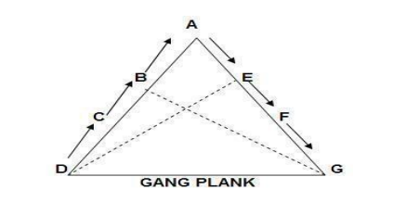

* In the figure given, if a person D has to communicate with person G , he will first send the communication upwards with the help of C, B to A and then downwards with the help of E and F to G which will take quite some time .
* Gang plank has been developed to facilitate quick communication between any two members in the organization.

**10. Order**

* This principle is concerned with proper & systematic arrangement of things and people.
* Arrangement of things is called material order and placement of people is called social order.
* The workplace facilities must be clean, tidy and safe for employees.Everything should have its place.

**11. Equity**

* The employees should be treated with kindness & equity
* Equity is essential to create and maintain cordial relations between the managers and sub-ordinate.
* Managers should be fair to staff at all times, both maintaining discipline as necessary and acting with kindness where appropriate.

**12. Stability of Tenure of Personnel**

* Fayol emphasized that employees should not be moved frequently from one job position to another
* Hence, the time, effort and money spent on training the worker will not go waste.
* Stability of job creates team spirit and a sense of belongingness among workers which ultimately increase the quality as well as quantity of work.

**13. Initiative**

* Workers should be encouraged to take initiative in the work assigned to them.
* Fayol advised that management should provide opportunity to its employees to suggest ideas, experiences& new method of work.
* Employees should be given the necessary level of freedom to create and carry out plans.

**14. Esprit de Corps**

* It refers to team spirit i.e. harmony in the work groups and mutual understanding among the members.
* Fayol cautioned the managers against dividing the employees into competing groups because it might damage the moral of the workers and interest of the undertaking in the long run.
* Organizations should strive to promote team spirit and unity.

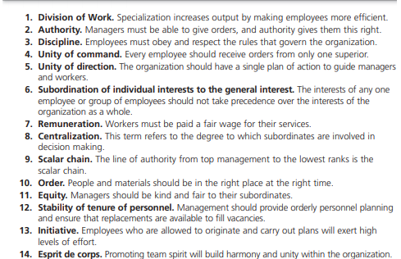

1. **Weber**

* Weber (pronounced VAY-ber) was a German sociologist who studied organizations.
* Writing in the early 1900s, he developed a theory of authority structures and relations based on an ideal type of organization he called a **bureaucracy**—a form of organization characterized by division of labour, a clearly defined hierarchy, detailed rules and regulations, and impersonal relationships.

1. Is Management Science or Art? Justify.

**Management – As Science**

* Science is a systematic **body of knowledge** relating to a specific field of study that contains general facts which explains a phenomenon.
* It establishes **cause & effect relationship** between two or more variables and underlines the principles governing the relationship.
* These principles are developed through scientific methods of observation and verification through **testing**.

**Cause and Effect Relationship**

* When metals are heated, they are expanded.
  + Cause - Heating
  + Effect - Expansion
* Similarly in a management, if workers are given bonus, fair wages they will work hard. But not treated in fair & just manner, reduces productivity.
  + Cause – Bonus/Fair wage
  + Effect – Better productivity

**Testing**

* The chemical combination of **Hydrogen and Oxygen** gives water.
* Similarly, in a management, principle of unity of command can be tested by comparing two persons – One having single boss and other having two bosses.
* Apparently, the performance of first is better than the second, because the very essence of a single boss is mixed with another.

**Management – As an Art**

An art requires :

* + Practical knowledge
  + Personal skill
  + Creativity
  + Perfection through practice
  + Goal orientation

**Practical Knowledge**

* Every art requires practical knowledge. Therefore learning of theory is not sufficient.
* It is very important to know practical application of theoretical principles.
* For instance, a manager can never be successful **just by obtaining degree**. He must know **how to apply** principles in real situation. This is obtained by **practical knowledge.**

**Personal skill**

* Although theoretical base may be same for every artist, each one has **his own style** and approach towards his job.
* We have many musicians, but **ARR stands out** when compared due to his personal skills. Similar in case of managers.

**Creativity**

* Every artist has an element of creativity.
* Management is also creative in nature.
* It combines human and non-human resources in an useful way so as to achieve desired results.

**Perfection through Practice**

* Practice makes a man perfect.
* Similarly managers learn through an **art of trial and error** initially, but application of management principles **over the years makes them perfect** in the job of managing.

**Goal Oriented**

* Every **art is result oriented** as it seeks to achieve concrete results.
* In the same manner, management is also directed towards accomplishment of **predetermined goals**.
* Managers use various resources like men, money, material, machinery and methods to help in the **growth of an organization**.

**Conclusion**

* Management is considered as **Science** because it has an organized body of knowledge which contains certain universal truth.
* Management is considered as an **Art** because managing requires certain skills which are personal possessions of managers.
* Science teaches us **“to know”**, and art teaches **“to do”**.
* For a manager to be successful he/she must acquire the knowledge of science and art of applying it.

**UNIT II**

1. **Strategy Management Process**

Strategic management is what managers do to develop the organization’s strategies.

Strategic Management can be defined as an art and science of formulating, implementing

and evaluating cross-functional decisions that enable an organization to achieve its objectives Organization’s strategies

This plans show how the organization will do whatever it’s in business to do, how it will compete successfully, and how it will attract and satisfy its customers in order to achieve its goals Important term often used in strategic management is business model, which simply is how a company is going to generate revenue.

It focuses on two things:

1. Whether customers will value what the company is providing

2. Whether the company can make any money doing that.

***Step 1: Identifying the organization’s current mission, goals, and strategies***

* Every organization needs a mission, It is a statement of its purpose. Defining the mission forces managers to identify what it’s in business to do.
* **For instance :** The mission of **Facebook** is “a social utility that connects you with the people around you.”

**Components of a Mission Statement**

* **Customers**
* **Markets**
* **Concern for survival, growth, and profitability:** financial stability

**Components of a Mission Statement**

* **Philosophy:** What are the firm’s basic beliefs, values, and ethical priorities?
* **Concern for public image:** How responsive is the firm to societal and environmental concerns?
* **Products or services:** What are the firm’s major products or services?
* **Technology:** Is the firm technologically current?
* **Self-concept:** What are the firm’s major competitive advantage and core

competencies?

* **Concern for employees:** Are employees a valuable asset of the firm?

***STEP 2: Doing an external analysis***

* Analysing the environment is a critical step. Managers do an external analysis so they know,
* For instance, what the **competition** is doing, what **pending legislation** might affect the organization, or what the **labour supply** is like in locations where it operates.
* Once they’ve analysed the environment, managers need to **pinpoint opportunities** that the organization can exploit and **threats** that it must counteract or buffer against.
* **Opportunities** are positive trends in the external environment; **threats** are negative trends.

***STEP 3: Doing an internal analysis***

* Internal analysis provides important information about an organization’s specific resources and capabilities.
* An organization’s resources are its **assets like financial, physical, human, and intangible** that it uses to develop, manufacture, and deliver products to its customers.
* After completing an internal analysis, managers should be able to **identify organizational strengths and weaknesses**.
* Any activities the organization does well or any unique resources that it has are called **strengths**.
* **Weaknesses** are activities the organization doesn’t do well or resources it needs but doesn’t possess.
* The combined external and internal analyses are called the **SWOT analysis,** which is an analysis of the organization’s **strengths, weaknesses, opportunities, and threats**.

***STEP 4: Formulating strategies***

* As managers formulate strategies, they should consider the realities of the external environment and their available resources and capabilities in order to design strategies that will help an organization achieve its goals.

***STEP 5: Implementing strategies***

* Once strategies are formulated, they must be implemented.
* No matter how effectively an organization has planned its strategies, performance will suffer if the strategies aren’t implemented properly.

***STEP 6: Evaluating Results***

* The final step in the strategic management process is evaluating results. How effective have the strategies been at helping the organization reach its goals?
* What adjustments are necessary? After assessing the results of previous strategies and determining that changes were needed.

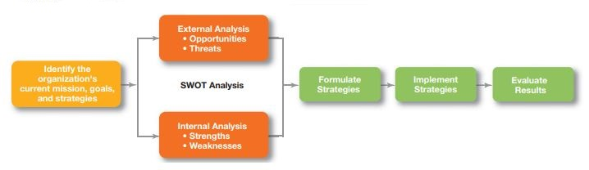

1. Outline the steps in decision making process

**1. Managers at all levels and in all areas of organizations make decisions**. That is, they make choices.

2. For instance, **top-level managers make decisions about their organization’s goals**, where to locate manufacturing facilities, or what new markets to move into.

3. Middle and **lower-level managers make decisions about production schedules**, product quality problems, pay raises, and employee discipline.

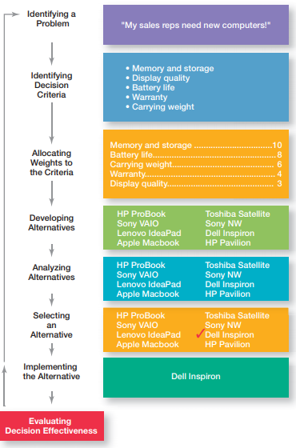

**1. Identifying a problem.**

* + Every decision starts with a problem, a discrepancy between an existing and a desired condition.
  + How do managers identify problems? In the real world, most problems don’t come with neon signs flashing “problem.”

**2. Identifying decision criteria.**

* + Once a manager has identified a problem, he or she must identify the **decision criteria** that are important or relevant to resolving the problem.
  + Every decision maker has criteria guiding his or her decisions even if they’re not explicitly stated.
  + The decision criteria for our sales rep are memory and storage capabilities, display quality, battery life, warranty, and carrying weight.

**3. Allocating weights to criteria.**

* + If the relevant criteria aren’t equally important, the decision maker must weight the items in order to give them the correct priority in the decision.
  + The simple way is to give the most important criterion a weight of 10 and then assign weights to the rest using that standard.
  + You could use any number as the highest weight.
  + Weights of the criteria for our example are below.

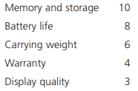

**4. Developing alternatives**

* + The fourth step in the decision-making process requires the decision maker to list viable alternatives that could resolve the problem.
  + The decision maker needs to be creative. And the alternatives are only listed, not evaluated just yet.
  + Below is the alternative development for our sales rep example.

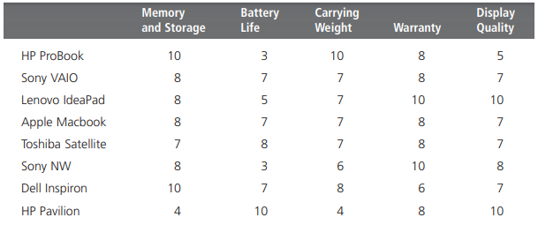

**5. Analyzing alternatives**

* + After identifying the alternatives, a decision maker must evaluate each one.
  + By using the criteria established in Step 2 and by giving a score to the evaluated alternative.
  + These data represent an assessment of the alternatives using the decision criteria, but not the weighting.
  + When you multiply each alternative by the assigned weight, you get the weighted alternatives.
  + The total score for each alternative, then, is the sum of its weighted criteria. Our sales rep analyzation is below.

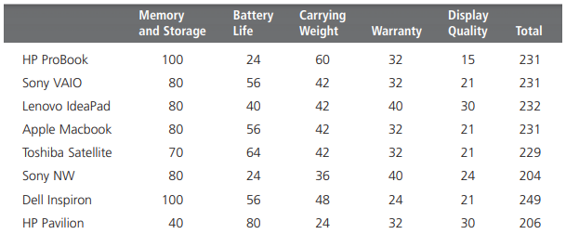

**6. Selecting an alternative.**

* + The sixth step in the decision-making process is choosing the best alternative or the one that generated the highest total in previous step.
  + In our example, the alternative with highest total, 249 is selected which is Dell Inspiron. Refer previous table.

**7. Implementing the alternative**

* + In step 7 in the decision-making process, you put the decision into action by conveying it to those affected and getting their commitment to it.
  + Importantly we must have the one who is implementing the decision must be present in our process. This will enable him to suggest during the course of decision process.
  + In our case, the purchase team and IT team had to be present in procuring Dell Inspiron laptop.

**8. Evaluating decision effectiveness.**

* + The last step in the decision-making process involves evaluating the outcome or result of the decision to see whether the problem was resolved.
  + If the evaluation shows that the problem still exists, then the manager needs to assess what went wrong.
  + Was the problem incorrectly defined? Were errors made when evaluating alternatives? Was the right alternative selected but poorly implemented?
  + The answers might lead you to redo an earlier step or might even require starting the whole process over.

1. Explain the different forecasting techniques during planning process.

**FORECASTING**

* Forecasting is an important part of planning and managers need forecasts that will allow them to predict future events effectively and in a timely manner.
* Environmental scanning establishes the basis for forecasts, which are predictions of outcomes. Virtually any component in an organization’s environment can be forecasted.
* Organizations collaborate on forecasts using an approach known as CPFR, which stands for collaborative planning, forecasting, and replenishment.
* CPFR provides a framework for the flow of information, goods, and services between retailers and manufacturers.
* Each organization relies on its own data to calculate a demand forecast for a par-ticular product.
* If their respective forecasts differ by a certain amount (say 10%), the retailer and manufacturer exchange data and written comments until they arrive at a more accurate forecast. Such collaborative forecasting helps both organizations do a better job of planning.

**FORECASTING EFFECTIVENESS.**

* The goal of forecasting is to provide managers with information that will facilitate decision making.
* For instance, prior to a holiday weekend at the Procter & Gamble factory in Lima,Ohio, managers were preparing to shut down the facility early so as not to have to pay employees for just sitting around and to give them some extra time off.

**Quantitative forecasting**:

Quantitative forecasting applies a set of mathematical rules to a series of past data to predict outcomes.

These techniques are preferred when managers have sufficient hard data that can be used.

1. Time series analysis : Fits a trend line to a mathematical equation and projects into the future by means of this equation.

2. Regression models : Predicts one variable based on known or assumed other variables

3. Econometric models : Uses a set of regression equations to simulate segments of the economy

4. Economic indicators: Uses one or more economic indicators to predict a future state of the economy

5. Substitution effect: Uses a mathematical formula to predict how, when, and under what circumstances a new product or technology will replace an existing one.

**Qualitative forecasting:**

* Qualitative forecasting uses the judgment and opinions of knowledgeable individuals to predict outcomes.
* Qualitative techniques typically are used when precise data are limited or hard to obtain.

1. Jury of opinion - Combines and averages the opinions of experts.

2. Salesforce composition - Combines estimates from field sales personnel of

customers expected purchases

3. Customer evaluation - Combines estimates from established customers

purchases

**UNIT-III**

1. Explain the characteristics and limitations of formal and informal organization

**Formal Organization:**

* Chester I Bernard defines formal organization as -"a system of consciously coordinated activities or forces of two or more persons. It refers to the structure of well-defined jobs, each bearing a definite measure of authority,responsibility and accountability."
* The essence of formal organization is conscious common purpose and comes into being when persons,
* Are able to communicate with each other
* Are willing to act, and
* Share a purpose.

**CHARACTERISTICS OF FORMAL ORGANIZATION**

* Formal organization structure is laid down by the top management to achieve organizational goals and prescribes the relationships amongst the people working in the organization. Its key characteristics are given below.
* The organization structures is consciously designed to enable the people of the organization to work together for accomplishing the common objectives of the enterprise
* Organization structure concentrates on the jobs to be performed and not the individuals who are to perform jobs.
* Individuals are fitted into jobs and positions and work as per the managerial decisions. Thus, the formal relations in the organization arise from the pattern of responsibilities that are created by the management.
* A formal organization is bound by rules, regulations and procedures.
* In a formal organization, the position, authority, responsibility and accountability of each level are clearly defined.
* Organization structure is based on division of labor and specialization to achieve efficiency in operations.
* A formal organization is deliberately impersonal. The organization does not take into consideration the sentiments of organizational members.
* The authority and responsibility relationships created by the organization structure are to be honored by everyone.
* In a formal organization, coordination proceeds according to the prescribed pattern.

**Advantages of formal organization**

* Reduces confusion
* Ensures specialization
* Fixing of responsibility
* Help in achievement of objectives
* Provide stability to the firm
* Increase organizational efficiency

**Disadvantages of formal organization**

* Reduced Initiatives
* Lack of match between objectives
* Delay in work due to rules & regulations
* Disturbance in relations
* Problem due to informal relations

**Informal organization**:

An informal organization is an organization which is not established by any formal authority, but arises from the personal and social relations of the people.

**Characteristics features of informal organization**

* Informal organization is not established by any formal authority. It is unplanned and arises spontaneously.
* Informal organizations reflect human relationships. It arises from the personal and social relations amongst the people working in the organization.
* Formation of informal organizations is a natural process. It is not based on rules, regulations and procedures.
* The inter-relations amongst the people in an informal organization cannot be shown in an organization chart.
* In the case of informal organization, the people cut across formal channels of communications and communicate amongst themselves.
* The membership of informal organizations is voluntary. It arises spontaneously and not by deliberate or conscious efforts.
* Membership of informal groups can be overlapping as a person may be member of a number of informal groups.
* Informal organizations are based on common taste, problem, language, religion, culture, etc. it is influenced by the personal attitudes, emotions, whims, likes and dislikes etc. of the people in the organization.

**Advantages of informal organization**

* Cooperation
* Sense of Belongingness (Stress free)
* Fast communication
* Aid (Help or assist ) on the job

**Disadvantages of informal organization**

* Resistance to change (sometimes management are not accepted )
* Clash (fight) in interest
* It is very much affected by the rumors
* Disturbance in relations
* Problem due to informal relations

1. Explain in detail about the nature and purpose of organization

**PURPOSE OF ORGANIZING:**

* Divides work to be done into specific jobs and departments.
* Assigns tasks and responsibilities associated with individual jobs.
* Coordinates diverse organizational tasks.
* Clusters jobs into units.
* Establishes relationships among individuals, groups, and departments.
* Establishes formal lines of authority.
* Allocates and deploys organizational resources

**NATURE OF ORGANIZATION:**

The key characteristics or nature of organization are given below:

Division of Works:

* Under division of work the entire work of business is divided into many departments The work of every department is further sub-divided into sub works.In this way each individual has to do the same work repeatedly which gradually makes that person an expert.

Coordination:

* Under organizing different persons are assigned different works but the aim of all these persons happens to be the same - the attainment of the objectives of the enterprise.
* Organization ensures that the work of all the persons depends on each other’s work even though it happens to be different. The work of one person starts from where the work of another person ends.

Plurality of Persons

* Organization is a group of many persons who assemble to fulfill a common purpose. A single individual cannot create an organization.

Common Objectives

* There are various parts of an organization with different functions to perform but all move in the direction of achieving a general objective.

Organization is a Machine of Management

* Organization is considered to be a machine of management because the efficiency of all the functions depends on an effective organization.
* In the absence of organization no function can be performed in a planned manner. It is appropriate to call an organization a machine of management from another point of view.
* It is that machine in which no part can afford tube ill-fitting or non-functional. In other words, if the division of work is not done properly or posts are not created correctly the whole system of management collapses.

Organization is a Universal Process

* Organization is needed both in business and nonbusiness organizations. Not only this, organization will be needed where two or mom than two people work jointly. Therefore, organization has the quality of universality.

Organization is a Dynamic Process

* Organization is related to people and the knowledge and experience of the people undergo a change.
* The impact of this change affects the various functions of the organizations.
* Thus, organization is not a process that can be decided for all times to come but it undergoes changes according to the needs.
* The example in this case can be the creation or abolition of a new post according to the need.

1. Explain in detail various types of Departmentalization and its advantages

After deciding what job tasks will be done by whom, common work activities need to be grouped back together so work gets done in a coordinated and integrated way.

How jobs are grouped together is called **Departmentalization.**

One specific type of team that more organizations are using is a **cross-functional team**, which is a work team composed of individuals from various functional specialties.

**Types of Departmentalization**

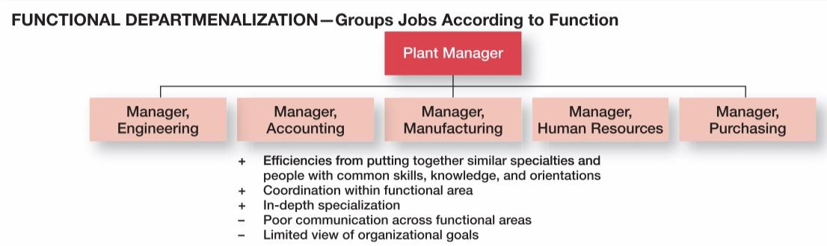

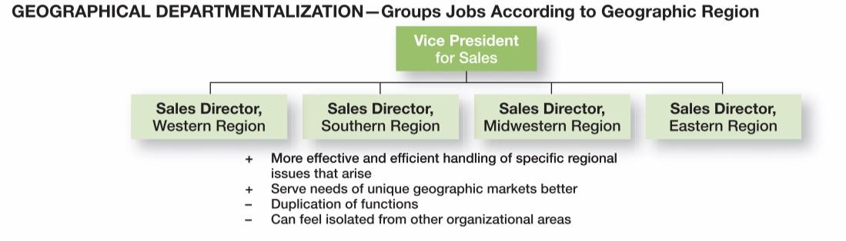

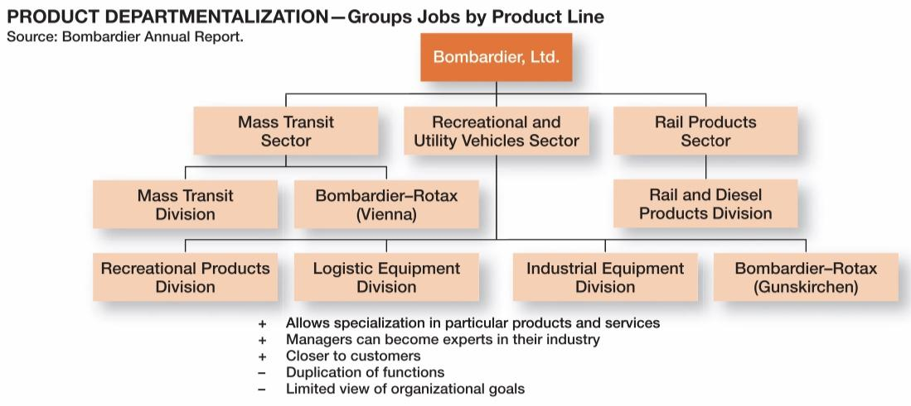

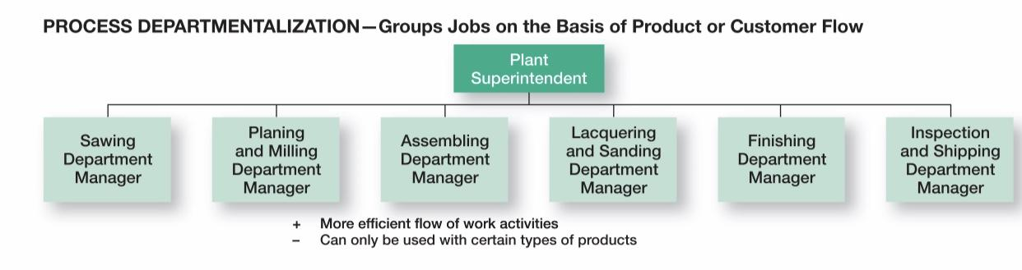

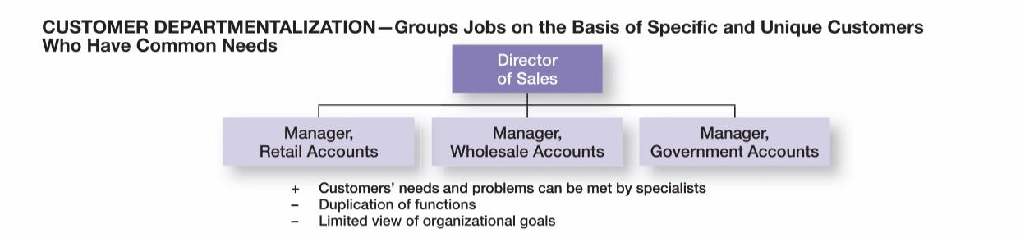

UNIT -IV

1. Explain in detail nature and purpose of motivation.

**Motivation is an Internal Feeling -**

* Motivation is a psychological phenomenon which generates in the mind of an individual the feeling that he lacks certain things and needs those things.

Motivation is a force within an individual that drives him to behave in a certain way.

**Motivation is Related to Needs -**

* Needs are deficiencies which are created whenever there is a physiological or psychological imbalance.
* In order to motivate a person, we have to understand his needs that call for satisfaction.

**Motivation Produces Goal-Directed Behavior-**

* Goals are anything which will alleviate a need and reduce a drive. An individual's behavior is directed towards a goal.

**Motivation can be either Positive or Negative**

* Positive or incentive motivation is generally based on reward.
* According to Flippo - "positive motivation is a process of attempting to influence others to do your will through the possibility of gain or reward".
* Negative or fear motivation is based on force and fear. Fear causes persons to act in a certain way because they are afraid of the consequences if they don't.

**Importance Of Motivation**

* A manager's primary task is to motivate others to perform the tasks of the organization.
* Therefore, the manager must find the keys to get subordinates to come to work regularly and on time, to work hard, and to make positive contributions towards the effective and efficient achievement of organizational objectives.
* Motivation is an effective instrument in the hands of a manager for inspiring the work force and creating confidence in it. By motivating the work force, management creates "will to work" which is necessary for the achievement of organizational goals.

1. Theories of motivation:

Refer unit IV notes from the college website from Page No:28 to 35

UNIT -V

1. Discuss the importance of control in organization. Explain the steps involved in the controlling Process

IMPORTANCE OF CONTROL IN ORGANIZATION:

* Planning can be done, an organizational structure created to facilitate efficient achievement of goals, and employees motivated through effective leadership.
* But there’s **no assurance that activities are going as planned** and the goals employees and managers are working towards are being attained.
* Control is important, because it’s the only way that managers know whether organizational goals are being met and if not, the reasons why.
* The value of the control function can be seen in three specific areas: **planning, empowering employees, and protecting the workplace.**
* **The second reason controlling is important is because of employee empowerment**.
* Many managers are reluctant to empower their employees because they fear something will go wrong for which they would be held responsible.
* But an effective control system can provide information and feedback on employee performance and minimize the chance of potential problems.
* **The final reason that managers control is to protect the organization and its assets**.

**CONTROL PROCESS:**

The control process is a three-step process,

* **Measuring actual performance**
* **Comparing actual performance against a standard**
* **Taking managerial action to correct deviations or to address inadequate standards.**

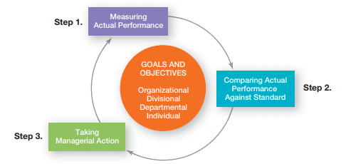

**Step 1. Measuring Actual Performance**

To determine what actual performance is, a manager must first get information about it. Thus, the first step in control is measuring.

**Step 1. Measuring Actual Performance**

**How we measure?**

Four approaches used by managers to measure and report actual performance,

* Personal observations
* Statistical reports
* Oral reports
* Written reports

**What we measure?**

**What control criteria might managers use?**

* Employee satisfaction or turnover and absenteeism rates can be measured.
* Keeping costs within budget is also a fairly common control measure
* A manager in a governmental agency might use applications typed per day, client requests completed per hour, or average time to process paperwork.

**Step 2. Comparing Actual Performance Against the Standard**

The comparing step determines the variation between actual performance and the standard. Although some variation in performance can be expected in all activities, it’s critical to determine an acceptable range of variation.

Deviations outside this range need attention.

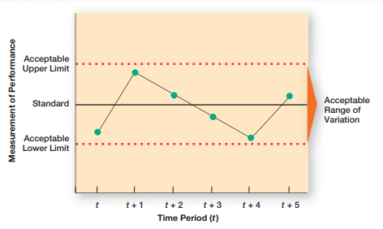

**Step 3. Taking Managerial Action**

Managers can choose among three possible courses of action:

* **Do nothing**
* **Correct the actual performance**
* **Revise the standards**

**Correct the actual performance**

* Depending on what the problem is, a manager could take different corrective actions.
* If unsatisfactory work is the reason for performance variations, the manager could correct it by **training programs, disciplinary action, changes in compensation practices**.
* One decision that a manager must make is whether to take **immediate corrective action**, which corrects problems at once to get performance back on track, **basic corrective action**, which looks at how and why performance deviated before correcting the source of deviation.
* Effective managers analyze deviations and if the benefits justify it, take the time to pinpoint and correct the causes of variance.

**Revise the standards**

* It’s possible that the variance was a result of an unrealistic standard—too low or too high a goal. In that situation, **the standard needs the corrective action, not the performance**.
* If **performance consistently exceeds the goal**, then a manager should look at whether the goal is too easy and needs to be raised.
* **Managers must be cautious about revising a standard downward**. It’s natural to blame the goal when an employee or a team falls short.
* If you believe the standard is realistic, fair, and achievable, tell employees that you expect future work to improve, and then take the necessary corrective action to help make that happen

1. What is budgetary control? Explain in detail the different techniques to control budget.

Refer page no: 24-28 from UNIT V in college websites.